# Shaheed Zulfikar Ali Bhutto Institute of Science & Technology

**COMPUTER SCIENCE DEPARTMENT**

**Fundamentals Of Programming (Lab)**

**Lab project #1**

Submitted To:

x

Group Members:

x

Project Title:

Automated Teller Machine (ATM)

Functionality:

* + - * + Performing given Action.
        + Produces Sound (while you enter correct or wrong information).
        + Display Color Screen.

Working:

* + - * + Deposit Cash.
        + Withdraw Cash.
        + Checking Balance.
        + Switching to another account

CODE:

*#include <iostream>*

*#include <windows.h> //for sound and color*

*using namespace std;*

*int main()*

*{*

*int amount=10000,pin=0,balance=0,a,c;*

*cout<<"\n****** Welcome to Team 007 ATM ****** \n";*

*account:*

*cout<<"\nEnter Your Pin Code: ";*

*cin>>pin;*

*if(pin==4423) //1st Account*

*{*

*Beep(523,500);*

*cout << "\nPin Approved!\n";*

*cout << "\n\t************************************";*

*cout << "\n\t* Welcome Raja Zia Un Nabi *";*

*switch_account:*

*cout << "\n\t* 1. Deposit *";*

*cout << "\n\t* 2. Withdraw *";*

*cout << "\n\t* 3. Check Balance *";*

*cout << "\n\t* 4. Switch Another Account *";*

*cout << "\n\t* 5. Exit *";*

*cout << "\n\t* *";*

*cout << "\n\t************************************";*

*cout << "\n\n";*

*system("Color 0A");*

*back_menu: //recall the case*

*cout << "\nSelect a Number: ";*

*cin>>c;*

*switch(c)*

*{*

*case 1:*

*cout<<"Enter your Deposit Amount: ";*

*cin>>a;*

*balance=a+amount;*

*cout<<"Your New Balance is: "<<balance;*

*goto back_menu; //for goto previous option*

*break;*

*case 2:*

*cout<<"Enter your Withdraw Amount: ";*

*cin>>a;*

*balance=amount-a;*

*if(a>amount)*

*{*

*cout<<"Account is Out of Balance.";*

*goto back_menu;*

*}*

*else*

*{*

*cout<<"Your New Balance is:"<<balance;*

*goto back_menu;*

*}*

*break;*

*case 3:*

*cout<<"Your Balance is : "<<amount;*

*goto back_menu;*

*break;*

*case 4:*

*goto account;*

*case 5:*

*cout<<"\n\t****** Thank You!!! ******";*

*break;*

*default:*

*cout<<"Invalid Option";*

*goto back_menu;*

*}*

*}*

*else if(pin==1234) //2nd Account*

*{*

*Beep(523,500);*

*cout << "\nPin Approved!\n";*

*cout << "\n\t************************************";*

*cout << "\n\t* Welcome Talha Shah *";*

*goto switch_account; //recall to another account*

*}*

*else if(pin==5555) //3rd Account*

*{*

*Beep(523,500);*

*cout << "\nPin Approved!\n";*

*cout << "\n\t************************************";*

*cout << "\n\t* Welcome M.Muneeb *";*

*goto switch_account;*

*}*

*else*

*{*

*cout<<"Invalid Pin";*

*goto account;*

*}*

*system("Color 04");*

*Beep(300,400);*

*return 0;*

*}*

Output:

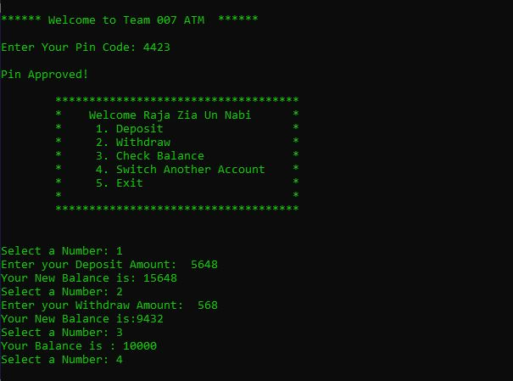

Switching Account Exit

